**Implement an Application (Your DA1 Application) in AngularJs, with minimum five components. Investigate how to perform Unit Testing for any two components in the Application, write appropriate test cases (at least five) for the Unit Testing. The document in the following format to be uploaded in the VTop:**

**Date: 03-19-2024**

**Name: S.MUSKAN**

**Reg. Number: 21691A28A1**

**Team Number: 04**

**Title of the Project : BLOOM CARE HOSPITALS**

**AIM:**

The project aims to develop a user-friendly Single Page Application (SPA) using AngularJS for the Bloom Care Hospital website. This SPA will consist of six primary pages: Login, Home, Contact Us, Payment, Doctors, about us, and Appointment. The Login page will provide secure authentication for users, ensuring data privacy. The Home page will serve as an informative hub, showcasing the hospital's services, facilities, and recent updates. On the Contact Us page, visitors can find contact information and a convenient form to reach out to the hospital. The Payment page will enable secure online transactions for services offered by the hospital, ensuring a seamless payment experience for patients. The Doctors page will feature profiles of medical practitioners, detailing their specialties and availability schedules. Lastly, the Appointment page will empower users to schedule appointments with doctors online, streamlining the appointment booking process. Overall, the project endeavors to create an intuitive and responsive web interface that enhances user experience, simplifies navigation, and provides essential functionalities tailored to the needs of patients and visitors of Bloom Care Hospital.

**INTRODUCTION:**

In an era marked by rapid technological advancements, Bloom Care Hospital endeavors to provide a seamless and intuitive online platform for its patients. Leveraging the power of AngularJS Single Page Application (SPA) technology, we are embarking on a transformative journey to redefine the digital healthcare experience.

**ANGULAR FEATURES:**

AngularJS, while powerful, is now quite outdated. Modern Angular (Angular 2 and above) is more commonly used for developing web applications. However, I can provide an overview of how AngularJS could be utilized in a hypothetical Bloom Care Hospital website with the mentioned pages:

1. **Login Page:**

Routing: AngularJS's ngRoute or ui-router can be used for defining routes. The login page would have its own route.

Controllers: A login controller would handle user authentication logic.

Services/Factories: Services can be used to communicate with the server for authentication.

1. **Home Page:**

Routing: A route for the home page would be defined.

Controllers: A home controller can manage the data to be displayed on the home page.

Directives: Directives can be used for reusable components on the home page.

1. **Contact Us Page:**

Routing: Define a route for the contact us page.

Controllers: A contact controller can handle form submission and interaction.

Validation: AngularJS provides form validation features to ensure valid input.

1. **Payment Page:**

Routing: Define a route for the payment page.

Controllers: Payment controller to manage payment logic.

Integration: Integration with payment gateways can be facilitated through AngularJS services.

1. **Doctors Page:**

Routing: Define a route for the doctors page.

Controllers: A doctors controller can fetch and display doctor information.

Services: Services can be used to fetch data from the server or an API.

1. **Appointment Page:**

Routing: Define a route for the appointment page.

Controllers: Appointment controller to handle appointment scheduling logic.

Services: Services can be used to communicate with the server to manage appointments. **7.About Us Page:**

Dynamic Content Rendering: AngularJS directives are utilized to dynamically render hospital information, including mission, values, and infrastructure details, ensuring seamless updates and maintenance.

Data Binding: Two-way data binding facilitates real-time updates to the page content, allowing users to interact with the information and receive immediate feedback without requiring page reloads.

Routing:AngularJS routing enables smooth navigation between different sections of the "About Us" page, allowing users to explore various aspects of the hospital's history, achievements, and quality standards effortlessly.

Two-way Data Binding: Changes in the model are automatically reflected in the view and vice versa.

Filters: For formatting data displayed on the UI.

Dependency Injection: AngularJS has a built-in dependency injection subsystem.

Testing Support: AngularJS provides support for unit testing controllers, services, and other components.

**COMPONENTS AND FUNCTIONS:**

1. **Login Component:** 
   * Template: HTML form for user login with username and password fields.
   * Controller: Handles user authentication and redirects to the appropriate page (e.g., home page) upon successful login.
   * Service: Provides methods to communicate with the backend server for user authentication.
2. **Home Component:** 
   * Template: Displays welcome message, hospital services, promotions, etc.
   * Controller: Fetches necessary data from backend services for display.
   * Service: Retrieves data such as promotions, hospital services, etc., from the backend server.
3. **Contact Us Component:** 
   * Template: Contains a form for users to submit inquiries/messages.
   * Controller: Validates form input and sends the inquiry/message to the backend for processing.
   * Service: Provides functionality to send contact form data to the backend server.
4. **Payment Component:** 
   * Template: Integrates payment gateway SDK or form for users to make payments.
   * Controller: Handles payment processing, validates payment details, and confirms successful transactions.
   * Service: Communicates with the payment gateway API to process payments securely.
5. **Doctors Component:** 
   * Template: Displays a list of doctors along with their specialties, photos, and contact information.
   * Controller: Retrieves doctor information from the backend and manages sorting/filtering of doctors.
   * Service: Fetches doctor data from the backend server and provides methods for filtering/sorting.
6. **Appointment Component:** 
   * Template: Allows users to schedule appointments by selecting a doctor, date, and time slot.
   * Controller: Handles appointment scheduling logic, including availability validation and booking confirmation.
   * Service: Communicates with the backend server to check doctor availability, schedule appointments, and manage booking details.

**7.About Us Component:**

Header Component:

* + Displays the hospital's logo and navigation links for easy access to other pages.

|  |
| --- |
| About Us Component:   * Contains detailed information about the hospital's mission, history, values, and infrastructure. * Utilizes AngularJS directives to render multimedia content, such as images, videos, or infographics. ***Login.component.html***   <divclass="login-container">  <imgclass="film"src="assets/images/film.png"alt=""/>  <divclass="logo">BloomCareHospitals!</div>  <divclass="desc">        Whether it's routine check-ups, complex surgeries, or rehabilitative therapies, BloomCare Hospital remains steadfast in its mission to promote healing, wellness, and a better quality of life for all.  </div>  <divclass="login-form">  <divclass="form-group">  <labelfor="uname">Username</label>  <input type="text" name="uname" class="form-control"  [(ngModel)]="username"  />  </div>  <divclass="form-group">  <labelfor="pword">Password</label>  <input type="password" name="pword" class="form-control"  [(ngModel)]="password"  />  </div>  <divclass="btn-container">  <divclass="error">{{ errorMsg }}</div>  <buttonclass="btnbtn-dark"(click)="login()">Login</button>  </div>  </div> </div>    ***Login.component.css*** |

|  |
| --- |
| .login-container { width: 100%; height: 100vh; background: rgb(255,72,72); background: linear-gradient(90deg, rgba(255,72,72,1) 0%, rgba(245,122,147,1) 49%, rgba(0,189,255,1) 100%); position: relative;  .logo { font-size: 70px; font-weight: bold; font-family: 'Creepster', cursive; letter-spacing: 10px; position: absolute; top: 50px; right: 50px;  } .desc { font-size: 34px; font-family: 'Aladin', cursive; letter-spacing: 5px; position: absolute; top: 200px; right: 50px; text-align: right; width: 1200px;  } .film { position: absolute; top: 50px; left: 50px; width: 618px;  }  .login-form { width: 500px; height: 300px; padding: 20px; background-color: #fff; border-radius: 10px; position: absolute; bottom: 50px; right: 50px;  box-shadow: 5px5px20px#383838;  .form-group { margin-top: 20px;  } label { font-weight: bold;  } |

|  |
| --- |
| .btn-container { position: relative;  .btn { margin-top: 30px;  } .error { position: absolute; top: 32px; right: 0px; color: red;  }  }  } }    ***Login.component.ts***  import{ Component, OnInit } from'@angular/core'; import{ Router } from'@angular/router'; import{ AuthService } from'../services/auth.service';    @Component({ selector:'app-login', templateUrl:'./login.component.html', styleUrls: ['./login.component.scss']  }) exportclassLoginComponentimplementsOnInit {  username=""; password=""; errorMsg="";    constructor(privateauth:AuthService, privaterouter:Router) { }  ngOnInit():void {  } login() {  if (this.username.trim().length===0) { this.errorMsg="Username is required"; } elseif (this.password.trim().length===0) { this.errorMsg="Password is required";  } else {  this.errorMsg=""; letres=this.auth.login(this.username, this.password); if (res===200) { this.router.navigate(['home']);  } |

|  |
| --- |
| if (res===403) { this.errorMsg="Invalid Credentials";  }  }  }  }  ***Home.component.html***  <bodyclass="fadeInAnimation">  <mainclass="fadeInAnimation">  <aside>  <div>  <h1><iclass="fas fa-seedling"></i> Welcome to Bloom Care  Hospital - Nurturing Health, Blooming Lives!</h1>  </div>    <div>  <h2>Hospital Highlights:</h2>  <ul>  <li><iclass="fas fa-star"></i> Patient-Centered Care:  Experience compassionate and personalized healthcare.</li>  <li><iclass="fas fa-trophy"></i> Award-Winning Services:  Recognized for excellence in patient care and innovation.</li>  <li><iclass="fas fa-hospital-alt"></i> State-of-the-Art  Facilities: Equipped with cutting-edge technology for optimal treatment.</li>  </ul>  </div>    <div>  <h2>Patient Resources:</h2>  <ul>  <li><iclass="fas fa-book"></i>Health Tips & Resources:  Access articles and resources for a healthier lifestyle.</li>  <li><iclass="fas fa-handshake"></i> Patient Testimonials:  Read heartwarming stories from our satisfied patients.</li>  <li><iclass="fas fa-briefcase"></i> Insurance Information:  Learn about accepted insurance plans and billing details.</li>  </ul>  </div>    <div>  <h2>Meet Our Experts:</h2>  <ul>  <li><iclass="fas fa-user-md"></i> Our Medical Team: Get to know our dedicated team of experienced healthcare professionals.</li> <li><iclass="fas fa-brain"></i> Specialized Care: Learn about our specialists and their areas of expertise.</li>  </ul> |

</div>

|  |
| --- |
| <div>  <h2>Language & Accessibility:</h2>  <ul>  <li><iclass="fas fa-globe"></i><ahref="#">Language Options</a>: Explore our website in multiple languages for your convenience.</li>  <li><iclass="fas fa-universal-access"></i> Accessibility  Features: Ensuring our website is accessible to all.</li>  </ul>  </div>    <div>  <h2>Subscribe & Stay Informed:</h2>  <ul>  <li><iclass="fas fa-envelope"></i> Newsletter Signup:  Receive health tips, event invitations, and exclusive offers.</li>  </ul>  </div>    </aside>    <section>  <divclass="container">  <divclass="section">  <h1>The Art of Healing: Bloom Care Hospital's Commitment to Your Well-Being</h1>  <p>At Bloom Care Hospital, we prioritize your health and well-being. Our commitment is to provide exceptional healthcare services with compassion, expertise, and cutting-edge technology.</p>    <h2>Why Choose Bloom Care?</h2>  <ul>  <liclass="heart">Patient-Centric Approach: Our dedicated team of healthcare professionals is committed to delivering personalized care tailored to your unique needs. Your well-being is our top priority.</li>  <liclass="medical">State-of-the-Art Facilities: Experience healthcare at its finest with our modern facilities equipped with the latest advancements in medical technology. We ensure a comfortable and healing environment for our patients.</li>  <liclass="user-md">Expert Physicians: Trust in the hands of our experienced and skilled physicians who are leaders in their respective fields. Our medical team is committed to providing the highest quality care.</li>  <liclass="tasks">Comprehensive Services: From routine check-ups to specialized treatments, Bloom Care Hospital offers a wide range |

of medical services. We strive to be your one-stop destination for all your

|  |
| --- |
| healthcare needs.</li>  </ul>    <h2>Our Specialties:</h2>  <ulclass="specialties">  <li>Cardiology: Ensuring a healthy heart for a healthier life.</li>  <li>Orthopedics: Restoring mobility and enhancing quality of life.</li>  <li>Maternity Care: Welcoming new beginnings with warmth and expertise.</li>  <li>Emergency Services: Your health can't wait, and neither do we.</li>  </ul>    <h2>Community-Centric Care:</h2>  <ulclass="community">  <li> Bloom Care Hospital is not just a healthcare institution; we are an integral part of the community. Through health awareness programs, outreach initiatives, and community events, we aim to promote a healthier and happier community.</li>  </ul>    <h2>Book Your Appointment Today:</h2>  <pclass="appointment">Take the first step towards a healthier future. Schedule an appointment with Bloom Care Hospital today. Your journey to optimal health begins here.</p>    <p>Your health, our priority. Bloom Care Hospital - Caring for You, Blooming with Wellness.</p>    <h2>Innovation in Healthcare</h2>    <p>At Bloom Care, we embrace the latest advancements in medical technology to ensure precise diagnoses and effective treatments. Our state-of-the-art facilities are designed to provide a healing environment for our patients, fostering a sense of comfort and well-being.</p>        <h2>Empowering Lives through Specialized Care</h2> <p>Our team of expert physicians, specializing in cardiology, orthopedics, maternity care, and emergency services, is dedicated to delivering high-quality care tailored to your unique needs. We understand that each patient is different, and our personalized approach reflects our commitment to your well-being.</p> |

<blockquoteclass="quote">

|  |
| --- |
| "Health is a state of complete physical, mental, and social well-being, and not merely the absence of disease."  </blockquote>  <pclass="author">- World Health Organization</p>  <h2>Transforming Healthcare: Bloom Care Hospital</h2>  <p>Bloom Care Hospital stands as a beacon of excellence in the realm of healthcare, redefining the standards of patient-centered care and medical innovation. With a legacy rooted in compassion and expertise, we embark on a mission to nurture health and empower lives. Our state-of-the-art facilities, coupled with a dedicated team of skilled professionals, ensure that each patient receives personalized treatment tailored to their unique needs. At Bloom Care Hospital, we don't just treat illnesses; we foster a culture of wellness, aiming to inspire and guide individuals towards a healthier, happier tomorrow. Join us in our commitment to transforming healthcare, one patient at a time.</p> </div>  </div>  </section>  </main>    <h3>OPD Consultation Hours</h3>  <tableborder="3"style="margin: 0 auto;">  <tralign="center">  <th>Sunday</th>  <th>Monday</th>  <th>Tuesday</th>  <th>Wednesday</th>  <th>Thursday</th> <th>Friday</th>  <th>Saturday</th>  </tr>  <tralign="center">  <td>Closed</td>  <td>9-5</td>  <td>9-5</td>  <td>9-5</td>  <td>9-5</td>  <td>9-5</td>  <td>10-2</td>  </tr>  </table>  <hr>  <divclass="contain">  <h3>Need a Doctor for Check-up?</h3>  <h2>Just Make An Appointment& You're Done!</h2>  <ahref="book.html"><buttonclass="button">Book Appointment</button></a> |

|  |
| --- |
| <h3>Embark on a virtual journey through the heart of healing-explore our hospital through an immersive video tour</h3>  <videosrc="hospital.mp4"width="500px"controlsautoplay></video>  </div>    <hr> </body>  ***Home.component.css***  body{ margin: 0px;  background: url('https://tse1.mm.bing.net/th?id=OIP.YZATN5F5-  EBxgsEHTNRWfwHaFj&pid=Api&P=0&h=180'); /* Adjust the path based on the actual location of the image */ background-size: cover; /* Optional: Adjust background size based on your preference */ background-position: center;  } main { margin-left: 20px; margin-right: 20px;  } h1 { text-align: center;  } aside { width: 20%; float: left; padding: 10px;  } section { width: 80%; float: left; padding: 10px;  }  @mediascreenand (max-width: 600px) { aside, section, article { width: 100%;  }  }  .container { display: flex; justify-content: space-between; |

|  |
| --- |
| align-items: center;  } body { margin: 0; padding: 0; box-sizing: border-box;  }    .contain { display: flex; flex-direction: column; align-items: center; justify-content: center; margin-top: -20px; padding: 20px; animation: fadeIn1sease-in-out;    }  @keyframesblinkOnce {  0% { opacity: 0;  } 50% {  opacity: 1;  } 100% {  opacity: 0;  }  }  h3, h2, button, video { margin-bottom: 20px; transition: opacity 1sease-in-out; animation: blinkOnce1sease-in-out;  } h3, h2, button, video:hover { opacity: 1;  } table { margin: 0auto; border-collapse: collapse; width: 80%; background-color: #f2f2f2; |

|  |
| --- |
| } th, td { padding: 12px; text-align: center; border: 1pxsolid#ddd;  } th { background-color: #f2f2f2; color: #333;  } tr:hover { background-color: #f5f5f5;  }  .button { position:relative; background-color: black; border:none; font-size:28px; color:#ffffff; padding:20px; width:500px; text-align:center; transition-duration:0.4s; text-decoration:none; overflow:hidden; cursor:pointer;  }    ***Home.component.ts***  import{ Component } from'@angular/core';  @Component({ selector:'app-home',  templateUrl:'./home.component.html', styleUrl:'./home.component.css'  })  exportclassHomeComponent {    } |

|  |
| --- |
| ***Appointment.component.html***  <body>  <divclass="cont">    <imgsrc="assets/bloomm.jpeg"width="300">  <h1>Appointment booking</h1>    <h2>Add patient details</h2>  <h4>Please provide details to continue to submit</h4>      <formaction="payments.html">    <labelfor="name">First Name:</label><br>  <inputtype="text"id="fname"name="name"requiredplaceholder="Enter your first name here"><br>  <labelfor="name">Last Name:</label><br>  <inputtype="text"id="lname"name="name"requiredplaceholder="Enter your last name here"><br>    <labelfor="start">Date of Birth:</label><br>  <inputtype="date"id="dob"name="trip-start"required><br>  <br>  Gender  <br>  <inputtype="radio"id="gender1"name="name"required> <labelfor="gender">Male</label>  <inputtype="radio"id="gender2"name="name"required>  <labelfor="gender">Female</label><br>  <br>  <labelfor="phone">Enter your phone number:</label><br>  <inputtype="tel"id="phone"name="phone"pattern="[0-9]{3}[0-9]{4}[0-  9]{3}"requiredplaceholder="Enter your mobile number"><br>  <labelfor="name">Native place:</label><br>  <inputtype="text"id="place"name="place"requiredplaceholder="Enter your place"><br>    <labelfor="email">Enter your email(optional):</label><br>  <inputtype="email"id="email"name="email"placeholder="Enter your Email"><br>  <labelfor="start">Date of appointment:</label><br>  <inputtype="date"id="doa"name="doa"required><br>    <labelfor="comment">Medical condition</label><br>    <textareaid="text"id="Medical condition"></textarea><br> |

|  |
| --- |
| Have you visited before?  <br>  <inputtype="radio"id="yes"name="name"required>  <labelfor="gender">Yes</label>  <inputtype="radio"id="no"name="name"required>  <labelfor="gender">No</label><br>    <buttontype="submit">Submit</button>  </form> </div> </body>    ***Appointment.component.css***  body { background-image: url('https://www.wallpapertip.com/wmimgs/99-  998859_background-image-for-hospital.jpg'); /* Replace 'assets/backgroundimage.jpg' with the path to your background image */ background-size: cover; background-position: center; background-repeat: no-repeat; margin: 0; padding: 0;  } center { margin-top: 50px;  } header { background-color: #f2f2f2; padding: 5px;  } headera { text-decoration: none; color: #333; margin-right: 10px;  } headera:hover { color: #000;  } h1 { text-align: center; color: black;  text-shadow: 2px2px4pxskyblue; margin-top: 20px;  } ul { list-style-type: none; |

|  |
| --- |
| margin: 0; padding: 0; overflow: hidden; background-color: #333; text-align: center; box-shadow: none;  } li { float: right;  } lia { display: block; color: white; text-align: center; padding: 14px16px; text-decoration: none;  } lia:hover:not(.active) { background-color: #f2aa4c;  }  .active { background-color: royalblue;  } h2, h4 { text-align: center;  } form { width: 70%; padding: 20px; background-color: none; border-radius: 10px; animation: fadeIn3sease;  float: center; /* Move the form to the left */ margin-left: 150px;  } label { font-weight: bold;  } input[type="text"], input[type="date"], input[type="tel"], input[type="email"], textarea { width: 50%; padding: 10px; margin-bottom: 10px; border: 1pxsolid#ccc; border-radius: 5px; |

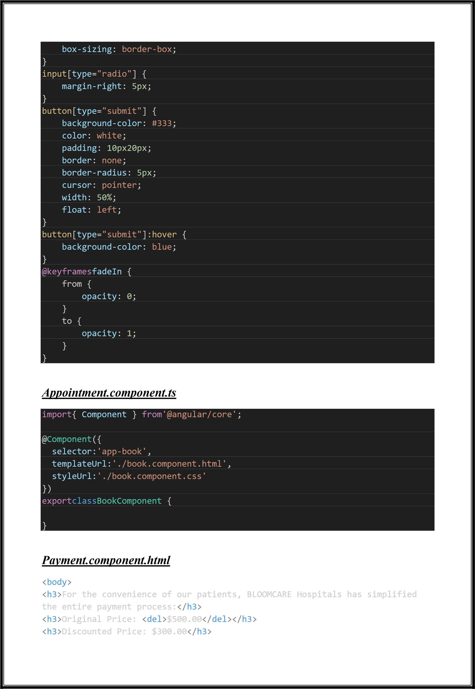

|  |
| --- |
| <ul>  <li><b>If you prefer to make payments in person, our friendly staff at the hospital's billing desk will be happy to assist you.</b></li>  <li><b>Secure payment gateway</b></li>  <li><b>Credit/Debit Card</b></li>    <imgsrc="https://pay.apollohospitals.com/images/payment/creditcard.svg"height= "30">  <li><b>Net Banking</b></li>    <imgsrc="https://pay.apollohospitals.com/images/payment/netbank.svg"height="30  "><br>  &All the Major banks  <li><b>Wallets</b></li>    <imgsrc="https://pay.apollohospitals.com/images/payment/wallets.svg"height="30  ">  <li><b>UPI</b></li>    <imgsrc="https://pay.apollohospitals.com/images/payment/upi.svg"height="30">  </ul>  <divclass="wrapper">    <h2>Payment form</h2>    <formname="paymentForm"action=""method="POST"onsubmit="returnvalidateForm()">  <divclass="input_group">  <divclass="input_box">  <inputtype="text"name="name"placeholder="Full  Name"requiredclass="name">  <iclass="fa fa-user icon"></i>  </div>  <divclass="input_box">  <inputtype="text"name="cardName"placeholder="Name on Card"requiredclass="name">  <iclass="fa fa-user icon"></i>  </div>  </div>  <divclass="input_group">  <divclass="input_box">  <inputtype="email"name="email"placeholder="Email  Address"requiredclass="name">  <iclass="fa fa-envelope icon"></i>  </div>  </div>  <divclass="input_box">    <inputtype="text"name="address"placeholder="Address"requiredclass="name"> |

|  |
| --- |
| <iclass="fa fa-map-marker icon"></i>  </div>  <divclass="input_group">  <divclass="input_box">    <inputtype="text"name="city"placeholder="City"requiredclass="name">  <iclass="fa fa-institution icon"></i>  </div>  </div>  <divclass="input_group">  <divclass="input_box">  <h4>Date of Birth</h4>    <inputtype="text"name="dobDay"placeholder="DD"requiredclass="dob">  <inputtype="text"name="dobMonth"placeholder="MM"requiredclass="dob">    <inputtype="text"name="dobYear"placeholder="YYYY"requiredclass="dob">  </div>  </div>  <divclass="input_group">  <divclass="input_box">  <h4>Payment Details</h4>  <inputtype="radio"name="pay"class="radio"id="bc1"checked>  <labelfor="bc1"><span><iclass="fa fa-cc-visa"></i>Credit  Card</span></label>  <inputtype="radio"name="pay"class="radio"id="bc2">  <labelfor="bc2"><span><iclass="fa fa-ccpaypal"></i>Paypal</span></label>  </div>  </div>  <divclass="input_group">  <divclass="input_box">  <inputtype="text"name="cardNumber"placeholder="CardNumber  1111-2222-3333-4444"requiredclass="name">  <iclass="fa fa-credit-card icon"></i>  </div>  </div>  <divclass="input_box">  <inputtype="text"name="cvv"placeholder="Card CVV  632"requiredclass="name">  <iclass="fa fa-user icon"></i>  </div>  <divclass="input_group">  <divclass="input_box">  <inputtype="text"name="expMonth"placeholder="Exp Month"requiredclass="name">  <iclass="fa fa-calendar icon"></i> |

</div>

</div>

<divclass="input_group">

|  |
| --- |
| <divclass="input_box">  <inputtype="text"name="expYear"placeholder="Exp year"requiredclass="name">  <iclass="fa fa-calendar-o icon"></i>  </div>  </div>  <divclass="input_box">  <inputtype="text"name="amount"placeholder="Enter  Amount"requiredclass="name">  <iclass="fa fa-money icon"></i>  </div>  <divclass="input_group">  <divclass="input_box">  <buttontype="submit">Pay Now</button>  </div>  </div>  </form>  </div>  </body> |

# Payment.component.css

|  |
| --- |
| body { margin: 0; padding: 0; box-sizing: border-box; background-image: url('https://www.wallpapertip.com/wmimgs/99-  998859_background-image-for-hospital.jpg'); /* Adjust the path based on your file structure */ background-size: cover; /* Cover the entire background */ background-position: center; /* Center the background */  background-repeat: no-repeat; /* Prevent background image from repeating  */  }    .wrapper{ background-color: #fff; width: 500px; padding: 25px; margin: 25pxauto0; box-shadow: 0px0px20pxrgba(0,0,0,0.5); border-radius: 10px; float:left; |

|  |
| --- |
| }  .wrapperh2{ background-color: #fcfcfc; color:#21cdd3; font-size: 24px; padding:10px; margin-bottom: 8px; text-align: center; border:1pxdashed#21cdd3;  }  .wrapperh4{ padding-bottom: 8px; color:#21cdd3;  }  .input_group{ margin-bottom: 8px; width:100%; position: relative; display:flex; flex-direction: row; padding:5px0;  }  .input_box{ width:100%; margin-right: 12px; position: relative;  }  .input_box:last-child{ margin-right: 0;  }  .input_box.name{ padding:14px10px14px50px; width:100%; background-color: #fcfcfc; outline:none; letter-spacing: 1px; transition: 0.3s; border-radius: 3px; color:#333;  }  .input_box.name:focus, .dob:focus{  -webkit-box-shadow:002px1px#21cdd3; -moz-box-shadow:002px1px#21cdd3; box-shadow: 002px1px#21cdd3; border:1pxsolid#21cdd3;  }  .input_box.icon{ width:48px; |

display:flex; justify-content: center;

align-items:center;

|  |
| --- |
| position:absolute; left:0px; bottom:0px; top:0px; color:#333; background-color: #f1f1f1; border-radius: 2px002px; transition:0.3s; font-size: 20px; pointer-events: none; border:1pxsolid#00000003; border-right: none;  }  .name:focus+.icon{ background-color: #21cdd3; color:#fff; border: 1pxsolid#21cdd3; border:none; transition:1s;  } .dob{ width:30%; padding:14px; text-align: center; background-color: #fcfcfc; transition:0.3s; outline:none; border:1pxsolid#c0bfbf; border-right: 3px;  } .radio{  display: none;  }  .input_boxlabel{ width:50%; padding:13px; background-color: #fcfcfc; display:inline-block;  text-align: center; border:1pxsolid#c0bfbf; |

}

.input_boxlabel:first-of-type{ border-top-left-radius: 3px;

|  |
| --- |
| border-bottom-right-radius: 3px; |

border-right: none;

}

|  |
| --- |
| .input_boxlabel:Last-of-type{ border-top-left-radius: 3px; border-bottom-right-radius: 3px;  }  .radio:checked+label{ background-color: #21cdd3; color:#fff; transition: 0.5s;  }  .input_boxbutton{ width:100%; background-color: #21cdd3; color:#fff; border:none; padding:15px; border-right: 4px; font-size: 16px; transition:all0.3sease; border-radius: 8px;  }  .input_boxbutton:hover{ cursor:pointer;  } |

# Payment.component.ts

|  |
| --- |
| import{ Component } from'@angular/core';    @Component({ selector:'app-payment',  templateUrl:'./payment.component.html', styleUrl:'./payment.component.css'  })  exportclassPaymentComponent {    } |

# Doctor.component.html

|  |
| --- |
| <body>  <formaction="book.html">  <h2style="color:rgb(179, 60, 106)">"People pay the doctor for his trouble; for his kindness they'll always remain in his debt."</h2> |

<inputtype="text"id="searchInput"size="25"onkeyup="searchDoctors()"placeholder

|  |
| --- |
| ="Search by doctor specialization">  <divid="doctorsContainer">  <br>  <br>  <divclass="doctor-info"> <imgsrc="https://encrypted-  tbn0.gstatic.com/images?q=tbn:ANd9GcRJsbgZqZrx-  95ZyvsKYEH7noyr7zeW1yZWkQ&usqp=CAU">  <divclass="doctor-details">  <p>Name: Satyendra Nath Dutta</p>  <p>Degree: MBBS, MD(Gen. Med.), DM(Cardio.)</p>  <p>Specialization: Cardiologist</p>  </div>  <buttontype="submit"class="button">Book Appointment</button>    </div>  <br>  <hr>    <divclass="doctor-info">  <imgsrc="https://encrypted-tbn0.gstatic.com/images?q=tbn:ANd9GcTIsuF-HNAYPoZM6k-sO69b531jmN0-GiFOQ&usqp=CAU">  <divclass="doctor-details">  <p>Name: Dr Rupesh Kumar</p>  <p>Degree: MBBS, DO, DNB</p>  <p>Specialization: Nephrologist</p>  </div>  <buttontype="submit"class="button">Book Appointment</button>  </div>  <br>  <hr>  <divclass="doctor-info"> <imgsrc="https://encrypted-  tbn0.gstatic.com/images?q=tbn:ANd9GcTiuGQ13zty30auXqonhkby9rpRBUsC6NjuJw&usqp= CAU">  <divclass="doctor-details">  <p>Name: Dr Shalini Prakah</p>  <p>Degree: MBBS, DGO, MRCOG (UK)</p>  <p>Specialization: Gynecologist</p>  </div>  <buttontype="submit"class="button">Book Appointment</button> |

</div>

<br>

<hr>

|  |
| --- |
| <divclass="doctor-info"> |

<imgsrc="https://encryptedtbn0.gstatic.com/images?q=tbn:ANd9GcSzIVtEl7oJQE3CS9_sdY0aqDMBGgku8oG9WA&usqp=

|  |
| --- |
| CAU">  <divclass="doctor-details">  <p>Name: Dr Vikram Adithya</p>  <p>Degree: MD, DM (Neuro)</p>  <p>Specialization: Neurologist</p>  </div>  <buttontype="submit"class="button">Book Appointment</button>  </div>  <br>  <hr>  <divclass="doctor-info">  <imgsrc="https://www.apollocradle.com/wpcontent/uploads/2020/07/Dr.-Sudha-Madhuri.jpg.webp">  <divclass="doctor-details">  <p>Name: Dr Sudha Madhuri</p>  <p>Degree: MBBS, DDVL</p>  <p>Specialization: Orthopedic Surgeon</p>  </div>  <buttontype="submit"class="button">Book Appointment</button>  </div>  <br>  <hr>  <divclass="doctor-info"> <imgsrc="https://encrypted-  tbn0.gstatic.com/images?q=tbn:ANd9GcRWT0cWeMsl0deSLPwN-  MN7akGMDhGqStglIg&usqp=CAU">  <divclass="doctor-details">  <p>Name: Dr Anupama s</p>  <p>Degree: MBBS MS(Gen Surg)</p>  <p>Specialization: General Surgeon</p>  </div>  <buttontype="submit"class="button">Book Appointment</button>  </div>  <br>  <hr>  <divclass="doctor-info"> <imgsrc="https://encrypted-  tbn0.gstatic.com/images?q=tbn:ANd9GcRAbcSRSn1QmPT4Nhae9TvtVqjZm3T1ntgXQg&usqp= CAU">  <divclass="doctor-details">  <p>Name: Dr Siddarth Varma</p>  <p>Degree: MBBS MS(Gen Surg)</p>  <p>Specialization: General Surgeon</p>  </div>  <buttontype="submit"class="button">Book Appointment</button> </div> |

<br>

<hr>

<divclass="doctor-info">

|  |
| --- |
| <imgsrc="https://www.asterhospitals.in/sites/default/files/2023-  02/dr-s-sathish-kumar-endocrinologist-diabetologist_0.jpg">  <divclass="doctor-details">  <p>Name: Dr S Satish Kumar</p>  <p>Degree: MBBS,MRCP(Endocrinology and Diabetes UK)</p>  <p>Specialization: Endocrinology , Diabetology</p>  </div>  <buttontype="submit"class="button">Book Appointment</button>  </div>  <br>  <hr>  <divclass="doctor-info"> <imgsrc="https://encrypted-  tbn0.gstatic.com/images?q=tbn:ANd9GcRVq4Bg2roiBW0CYQX3ec5UGhlnq4FTxDVsHQ&usqp= CAU">  <divclass="doctor-details">  <p>Name: Dr Ankush Chanda</p>  <p>Degree: MBBS, MD ( Radiation Oncologist), PDCR, CC  <p>Specialization: Oncologist</p>  </div>  <buttontype="submit"class="button">Book Appointment</button>  </div>  <br>  <hr>  <divclass="doctor-info"> <imgsrc="https://encrypted-  tbn0.gstatic.com/images?q=tbn:ANd9GcQFUo1kRqD3SLmmfV3XTNI6h5omvonXNnZA3A&usqp= CAU">  <divclass="doctor-details">  <p>Name: Dr Naveen Babu</p>  <p>Degree: MBBS, DNB Anaesthesia</p>  <p>Specialization: Anesthesiologist</p>  </div>  <buttontype="submit"class="button">Book Appointment</button>  </div>  </div>        <br>  <hr> |

</form>

</body>

|  |
| --- |
| ***Doctor.component.css***  .doctor-info { margin-bottom: 40px; display: flex; align-items: center;  }  .button { background-color: #aa2304; border: none; color: white; padding: 15px32px; text-align: center; text-decoration: none; display: inline-block; font-size: 16px; margin: 4px2px; cursor: pointer;  } a:link, a:visited { background-color: rgb(255, 255, 255); color: black; border: 2pxsolidgreen; padding: 10px20px; text-align: center; text-decoration: none; display: inline-block;  } a:hover, a:active { background-color: green; color: rgb(255, 255, 255);  } img { border-radius: 20px;  } body {  background-color: rgb(173, 228, 230); border: 10pxsolidskyblue; border-radius: 12px; padding: 5px;  color:rgb(179, 96, 60)  } p{  font-family: 'Lucida Sans', 'Lucida Sans Regular', 'Lucida Grande',  'Lucida Sans Unicode', Geneva, Verdana, sans-serif;  }  .doctor-infoimg { margin-right: 20px; |

}

.doctor-details {

|  |
| --- |
| flex: 1;  } |

# Doctor.component.ts

|  |
| --- |
| import{ Component } from'@angular/core';    @Component({ selector:'app-doctor', templateUrl:'./doctor.component.html', styleUrl:'./doctor.component.css'  }) exportclassDoctorComponent {    } |

# About.component.html

|  |
| --- |
| <body>  <divclass="content"><i>    <img src="images/bloomm.jpeg"width="300"border-radius="8px">  <h1>BLOOMCARE Hospitals-The Journey This Far</h1>  <h3style="color: mediumvioletred;"><i>Promising a World of Good Health</i></h3>  <p>From starting out as a vision of one man's dream to the reality of revolutionizing the health care industry, we are proud to be the flag bearers of this paradigm shift with our clinical excellence, patient centricity and ethical practices integral to healthcare.  BLOOMCARE Hospitals is one of India's foremost multi-speciality healthcare providers catering to both Indian and international patients. We are a part of the BLOOMCARE Education and Medical Group (BCEMG), a leader in the areas of education and healthcare. With a group of 33 hospitals spread over 17 cities, we are the second-largest hospital chain in India. To manage such a large network of hospitals, we have different entities that ensure proper functioning, smooth operations and overall patient satisfaction  </p>  <dl>  <b><dt>Vision:</dt></b>  <dd>Be the Destination of choice for the communities we serve.Most preferred and respected healthcare organisation in every location where we operate.</dd> |

|  |
| --- |
| <b><dt>Mission:</dt></b>  <dd>To Enhance “GROWTH, DIFFERENTIATION & PEOPLE” and to serve our patients with a smile.</dd>  <b><dt>Growth:</dt></b>  <dd> To augment patient volumes in existing and new locations through current and new engines of growth.</dd>  <b><dt>Differentiation:</dt></b>  <dd>By innovation in delivering clinical excellence and enhancing the patient experience.</dd>  </dl>    <h2style="color: blue;">Why BLOOMCARE??</h2>  <h1style="color: maroon;">Online and Offline Consultations</h1>  <p>BLOOOMCARE doctors are available for walk-in or Online Consultations</p>  <imgsrc="images/online1.png"width="500"height="500">  <br>  <h1style="color: maroon;">Safest Treatment Methods</h1>  <p>Accurate diagnosis and safest treatment methods at an affordable cost.</p>  <imgsrc="images/safe1.webp"width="450"height="450">  <h1style="color: maroon;">Complete Guidance for Chronic Diseases</h1> <p>We provide complete guidance in selecting the best doctor who can provide the safest treatment for your chronic disease</p>  <imgsrc="images/doc.jpg"width="450"height="450">  <h1style="color: maroon;">100+ medical specialities</h1>  <p>We have several doctors who specialize in more than 100 medical specialities</p>    <imgsrc="images/doc2.jpg"width="200"height="300" >  <h1style="color: maroon;">Our Success Stories</h1>  <p>BLOOMCARE Hospitals is one of the leading healthcare providers in the country.For over many decades,the BLOOMCARE group has been providing a diverse range of facilities and services of unparalleled quality.And to provide you with even more assistance and hassle-free care,BLOOMCARE Hospitals is glad to offer you the facility of premium consultation.</p>  <div>  <h2>75+</h2>  <p>Lakhs lives Touched</p>  <hr>  <h2>60+</h2>  <p>Years of Experience</p>  <hr>  <h2>2000+</h2>  <p>Expert Doctor</p>  <hr>  <h2>55+</h2> |

|  |
| --- |
| <p>specialities</p>  </div>    ***About.component.css***  /* CSS for the component */    .content {  padding: 20px;  }    .contentimg {  border-radius: 8px;  }    .contenth1 { color: #800000;  }    .contenth2 { color: #000080;  }    .contenth3 { color: mediumvioletred;  }    .contentp { color: black;  }    .contentdl {  margin-top: 20px;  }    .contentdldt { color: blue;  }    .contentdiv {  margin-top: 20px;  }    .contentdivh2 { display: inline-block; margin-right: 10px;  } |

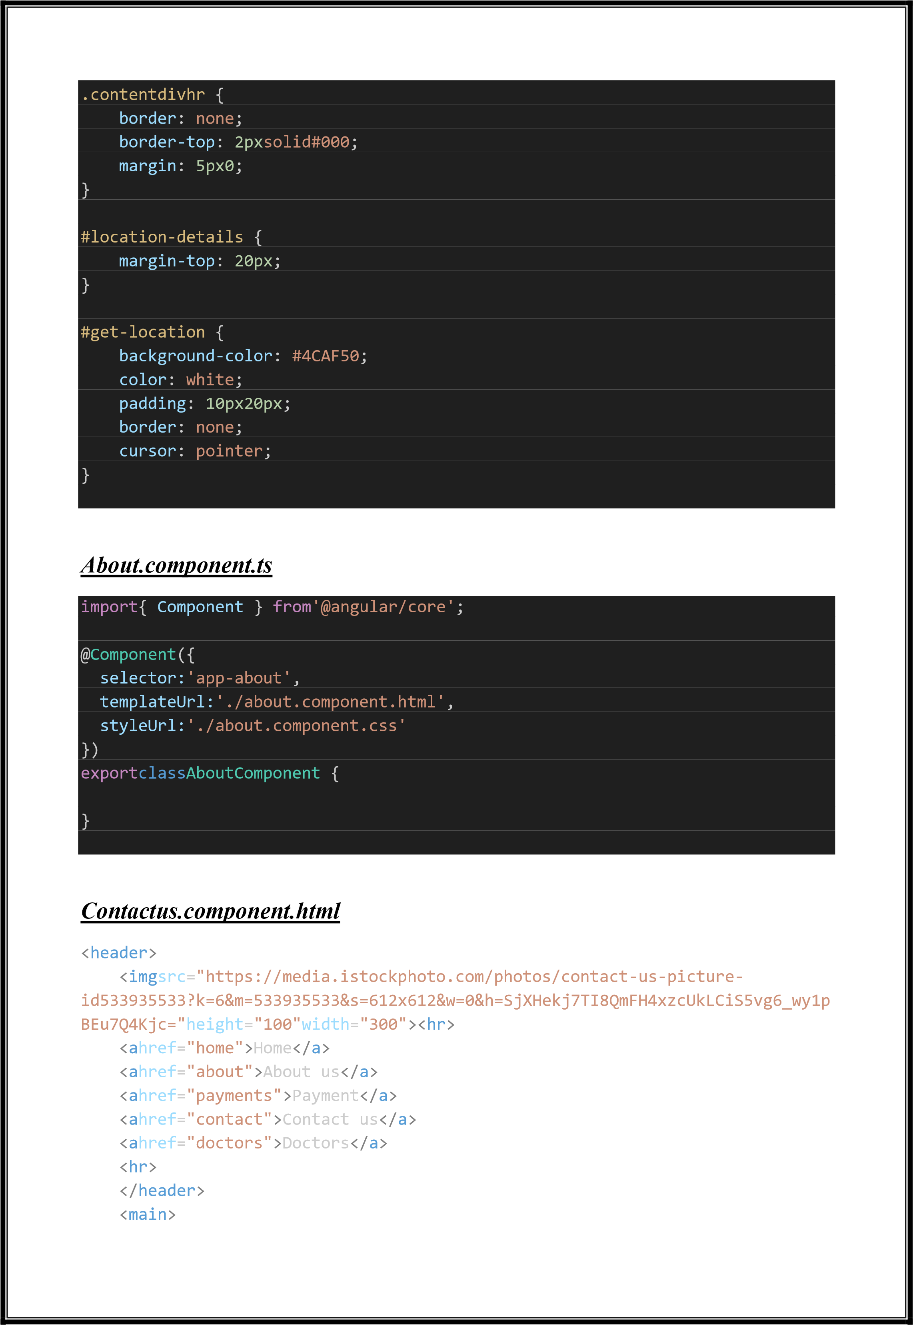

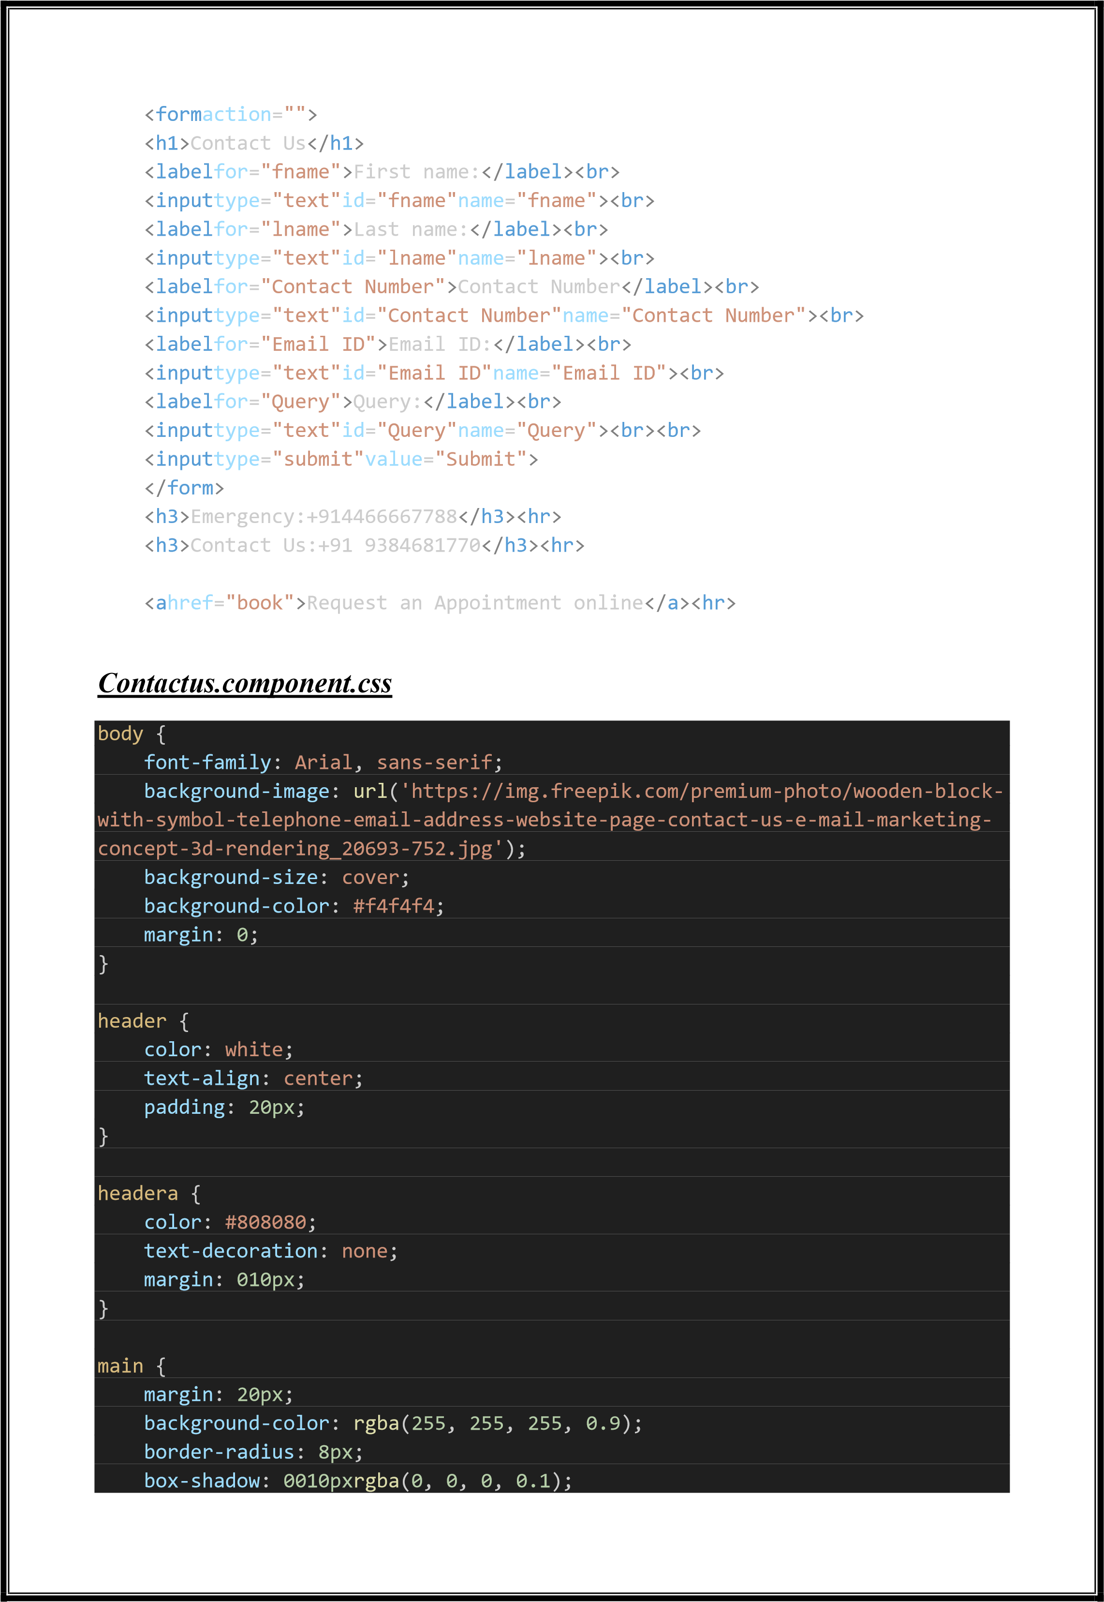

|  |
| --- |
| padding: 20px;  } formh1 { text-align: center; color: #333;  } label { display: block; margin: 10px05px; color: #555;  } input { width: 100%; padding: 10px; margin-bottom: 10px; border: 1pxsolid#ccc; border-radius: 4px; box-sizing: border-box;  } input[type="submit"] { background-color: #333; color: white; cursor: pointer;  } input[type="submit"]:hover { background-color: #555;  } h3, hr {  margin-top: 20px; margin-bottom: 20px; color: #555;  } a {  color: #333;  text-decoration: none;  } a:hover { text-decoration: underline;  } |

***Contactus.component.ts***

mport

{

Component

}

from

'@angular/core'

;

@

Component

({

selector:

'app

-

contact'

,

templateUrl:

'./contact.component.html'

,

styleUrl:

'./contact.component.css'

})

export

class

ContactComponent

{

}

**Description of Routing and Navigation in the Project**

**1**

**. Login**

**:**

This page will contain the login form where users can log in to their

accounts.

**. Home**

**:**

**2**

This is the main landing page of the website where users will be

redirected after logging in. It may contain information about the hospital,

services offered, etc.

**. Contact Us:**

**3**

This page will display contact information for the hospital, such

as address, phone number, email, and possibly a contact form for users to reach

out.

**:**

**. Payment**

**4**

This page will handle payment

-

related functionalities, such as

accepting payments for services offered by the hospital.

**:**

**. Doctors**

**5**

This page will display information about the doctors working at the

hospital, their specialties, and possibly allow users to book appointments with

them.

**:**

**.Appointment**

**6**

This page will allow users to schedule appointments with

doctors at the hospital.

**:**

**.About Us**

**7**

Defined a route for the About Us page in the AngularJS routing

module.Specified the URL path ("/about") and associated it with the About Us

component.

***App***

***-***

***routing.module.ts***

import

{

NgModule

}

from

'@angular/core'

;

import

{

RouterModule

,

Routes

}

from

'@angular/router'

;

import

{

DoctorComponent

}

from

'./doctor/doctor.component'

;

import

{

HomeComponent

}

from

'./home/home.component'

;

import{ PaymentComponent } from'./payment/payment.component';

|  |
| --- |
| import{ BookComponent } from'./book/book.component'; import{ LoginComponent } from'./login/login.component'; import{ AboutComponent } from'./about/about.component';  constroutes:Routes= [  { path:'', redirectTo:'login',pathMatch:'full'},  { path:'login', component:LoginComponent},  { path:'doctor', component:DoctorComponent},  { path:'about', component:AboutComponent},  { path:'home', component:HomeComponent},  { path:'payment', component:PaymentComponent},  { path:'book', component:BookComponent},  { path:'**', component:LoginComponent}  ];    @NgModule({ imports: [RouterModule.forRoot(routes)], exports: [RouterModule]  }) exportclassAppRoutingModule{ } |

# App-component.html

|  |
| --- |
| <router-outlet></router-outlet> |

# App-component.css

|  |
| --- |
| header { width:100%; padding:20px50px; background-color:#222; display:flex; justify-content: space-between; align-items: center;  } headerh2{ color:#fff;  } headerul{  display:flex;  } headerulli{ |

|  |
| --- |
| margin-left: 20px;  } headerullia{ padding:5px10px; font-weight:500; color:#fff;  } headerullia:hover{ background-color: lightgray; color:#000;  } footer { display: block; color:#ffffff; clear: both; background-color:#333333; text-align: center; padding: 25px;  }  .site-footer { background-color: hsl(0, 0%, 86%); padding: 20px0;  }  .container { display: flex; justify-content: space-between; align-items: center;  }    .follow,  .app-install, .payments {  text-align: center; margin-bottom: 20px;  }    .iconi,  .app-installimg, .paymentsimg { margin: 0px;  } hr { border: 0; border-top: 1pxsolid#ddd;  }    .copyright { |

text-align: center;

font-size: 14px;

}

|  |
| --- |
| .address { font-style: normal;  } |

# App-component.ts

|  |
| --- |
| import{ Component } from'@angular/core';    @Component({ selector:'app-root', templateUrl:'./app.component.html', styleUrl:'./app.component.css'  }) exportclassAppComponent {  title='Single-page-application';  } |

**Description of Service and Possible Dependencies in the Project**

1. AuthenticationService: Handles user authentication and authorization.
   * Dependencies: HttpClient (for making HTTP requests to the server for authentication), Router (for navigating to different pages after login/logout).
2. UserService: Manages user-related operations like fetching user details, updating user information, etc.
   * Dependencies: HttpClient (for communicating with the server to fetch/update user details).
3. AppointmentService: Deals with appointment-related operations such as scheduling appointments, fetching appointment details, etc.
   * Dependencies: HttpClient (for communicating with the server to manage appointments), UserService (to fetch user details for appointments).
4. DoctorService: Handles doctor-related operations like fetching the list of doctors, retrieving doctor details, etc.

-Dependencies: HttpClient (for fetching doctor information from the server).

1. PaymentService: Manages payment operations such as processing payments, retrieving payment history, etc.
   * Dependencies: HttpClient (for communicating with the payment gateway or server for payment processing).
2. ContactService: Handles contact-related operations like sending inquiries, fetching contact information, etc.
   * Dependencies: HttpClient (for submitting contact forms or fetching contact details from the server).
3. AboutService: Manages content and information related to the hospital.
   * Dependencies: HttpClient (for fetching about us content from the server). ***Login.component.spec.ts***

|  |
| --- |
| import{ ComponentFixture, TestBed } from'@angular/core/testing';  import{ LoginComponent } from'./login.component';  describe('LoginComponent', () => { letcomponent:LoginComponent; letfixture:ComponentFixture<LoginComponent>;    beforeEach(() => {  TestBed.configureTestingModule({ declarations: [LoginComponent]  }); fixture=TestBed.createComponent(LoginComponent); component=fixture.componentInstance; fixture.detectChanges();  }); it('should create', () => { expect(component).toBeTruthy();  });  }); |

# Home.component.spec.ts

|  |
| --- |
| import{ ComponentFixture, TestBed } from'@angular/core/testing';  import{ HomeComponent } from'./home.component';  describe('HomeComponent', () => { letcomponent:HomeComponent; letfixture:ComponentFixture<HomeComponent>; |

beforeEach(async () => { awaitTestBed.configureTestingModule({

|  |
| --- |
| declarations: [HomeComponent]  })  .compileComponents();  fixture=TestBed.createComponent(HomeComponent); component=fixture.componentInstance; fixture.detectChanges();  }); it('should create', () => { expect(component).toBeTruthy();  });  }); |

# Appointment.component.spec.ts

|  |
| --- |
| import{ ComponentFixture, TestBed } from'@angular/core/testing';  import{ BookComponent } from'./book.component';  describe('BookComponent', () => { letcomponent:BookComponent; letfixture:ComponentFixture<BookComponent>;  beforeEach(async () => { awaitTestBed.configureTestingModule({ declarations: [BookComponent]  })  .compileComponents();  fixture=TestBed.createComponent(BookComponent); component=fixture.componentInstance; fixture.detectChanges();  });  it('should create', () => { expect(component).toBeTruthy();  });  }); |

# Payment.component.spec.ts

import{ ComponentFixture, TestBed } from'@angular/core/testing';

|  |
| --- |
| import{ PaymentComponent } from'./payment.component';  describe('PaymentComponent', () => { letcomponent:PaymentComponent; letfixture:ComponentFixture<PaymentComponent>;  beforeEach(async () => { awaitTestBed.configureTestingModule({ declarations: [PaymentComponent]  })  .compileComponents();  fixture=TestBed.createComponent(PaymentComponent); component=fixture.componentInstance; fixture.detectChanges();  }); it('should create', () => { expect(component).toBeTruthy();  });  }); |

# Doctor.component.spec.ts

|  |
| --- |
| import{ ComponentFixture, TestBed } from'@angular/core/testing';  import{ DoctorComponent } from'./doctor.component';  describe('DoctorComponent', () => { letcomponent:DoctorComponent; letfixture:ComponentFixture<DoctorComponent>;    beforeEach(async () => {  awaitTestBed.configureTestingModule({ declarations: [DoctorComponent]  })  .compileComponents();  fixture=TestBed.createComponent(DoctorComponent); component=fixture.componentInstance; fixture.detectChanges();  }); it('should create', () => { expect(component).toBeTruthy(); |

});

});

# About.component.spec.ts

|  |
| --- |
| import{ ComponentFixture, TestBed } from'@angular/core/testing';  import{ AboutComponent } from'./about.component';  describe('AboutComponent', () => { letcomponent:AboutComponent; letfixture:ComponentFixture<AboutComponent>;  beforeEach(async () => { awaitTestBed.configureTestingModule({ declarations: [AboutComponent]  })  .compileComponents();  fixture=TestBed.createComponent(AboutComponent); component=fixture.componentInstance; fixture.detectChanges();  }); it('should create', () => { expect(component).toBeTruthy();  });  }); |

# Contactus.component.spec.ts

|  |
| --- |
| import{ ComponentFixture, TestBed } from'@angular/core/testing';    import{ ContactComponent } from'./contact.component';    describe('ContactComponent', () => { letcomponent:ContactComponent; letfixture:ComponentFixture<ContactComponent>;    beforeEach(async () => {  awaitTestBed.configureTestingModule({ declarations: [ContactComponent]  })  .compileComponents(); |

|  |
| --- |
| fixture=TestBed.createComponent(ContactComponent); component=fixture.componentInstance; fixture.detectChanges();  }); it('should create', () => { expect(component).toBeTruthy();  }); });    ***App-component.spec.ts***  import{ TestBed } from'@angular/core/testing'; import{ RouterTestingModule } from'@angular/router/testing'; import{ AppComponent } from'./app.component';  describe('AppComponent', () => { beforeEach(async () => { awaitTestBed.configureTestingModule({ imports: [  RouterTestingModule  ],  declarations: [  AppComponent  ],  }).compileComponents();  }); it('should create the app', () => { constfixture=TestBed.createComponent(AppComponent); constapp=fixture.componentInstance; expect(app).toBeTruthy();  }); it(`should have as title 'Single-page-application'`, () => { constfixture=TestBed.createComponent(AppComponent); constapp=fixture.componentInstance; expect(app.title).toEqual('Single-page-application'); }); it('should render title', () => { constfixture=TestBed.createComponent(AppComponent); fixture.detectChanges();  constcompiled=fixture.nativeElementasHTMLElement;  expect(compiled.querySelector('h1')?.textContent).toContain('Hello,  Single-page-application');  });  }); |

**Screenshots:**

**Login Page**

**Home Page**

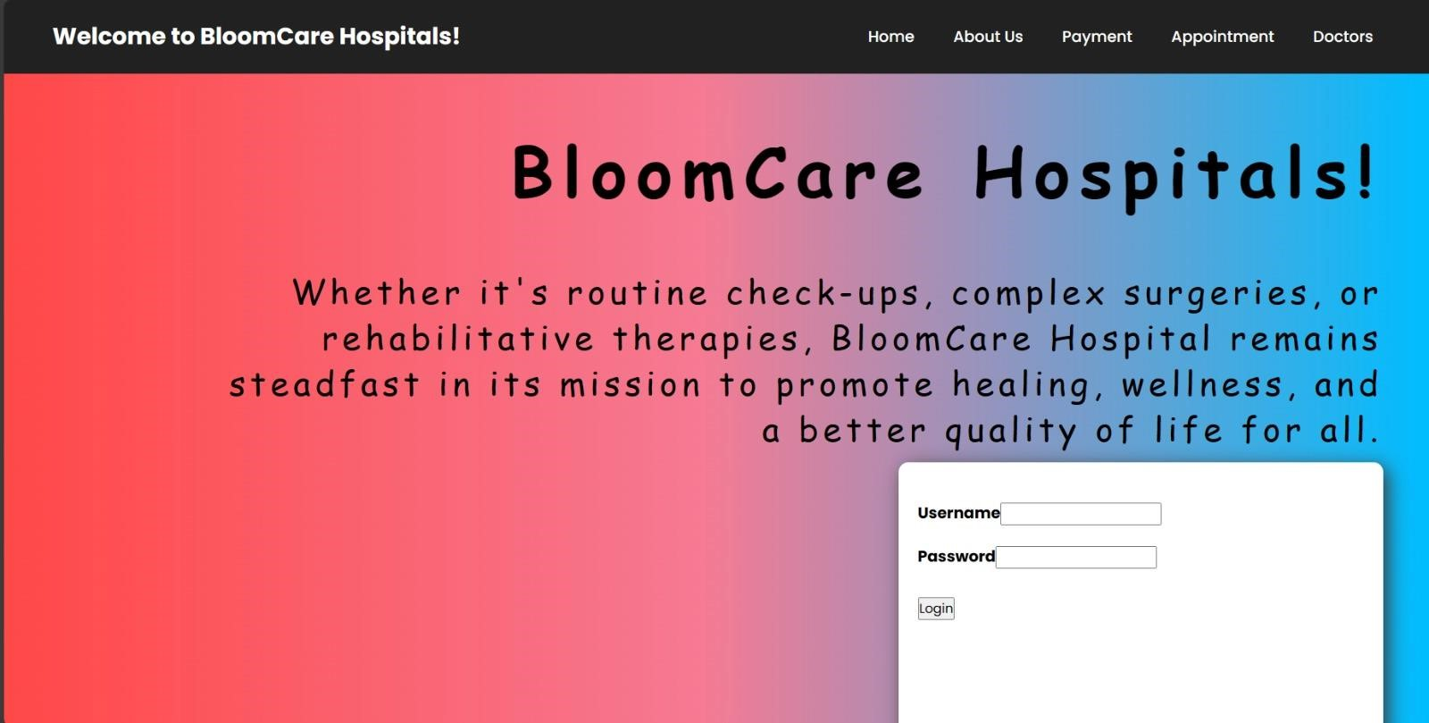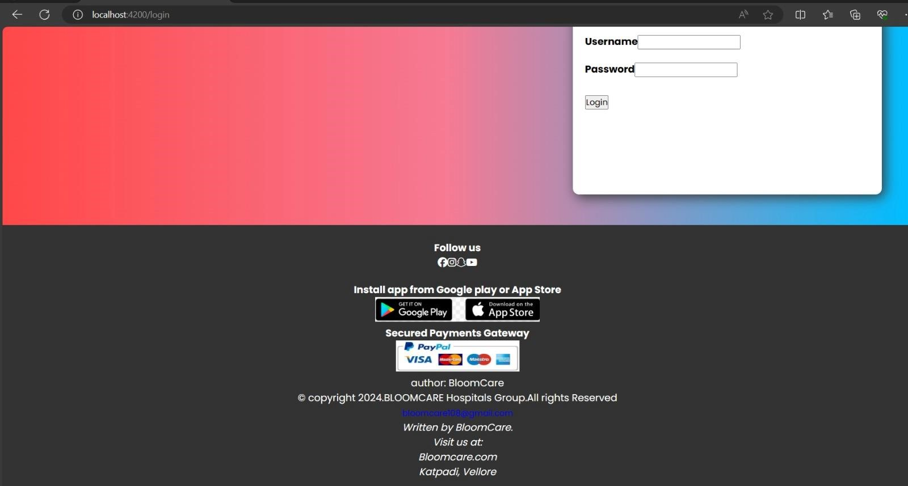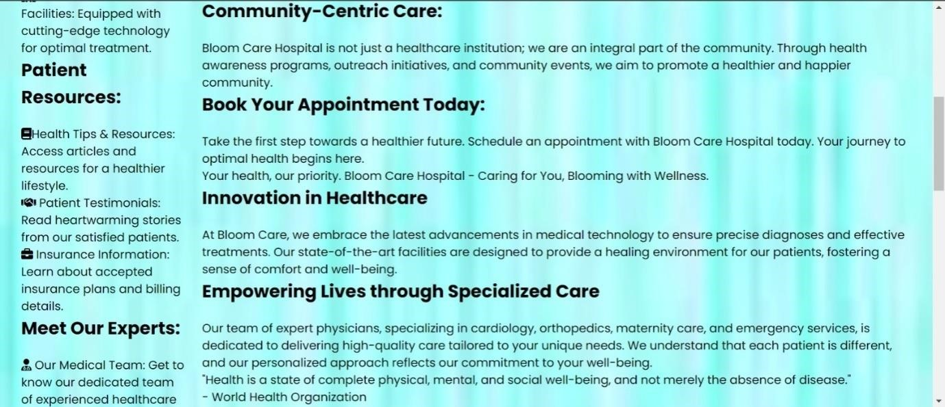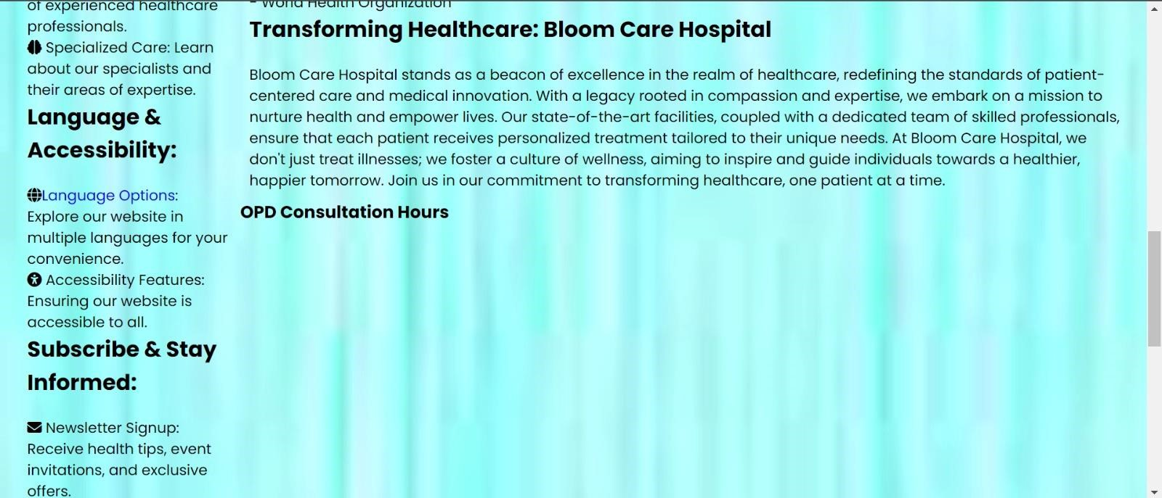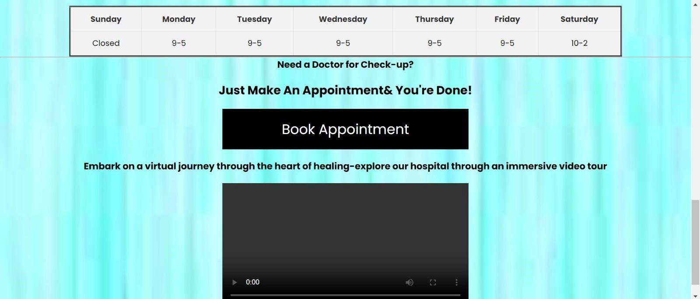

**Appointment Page**

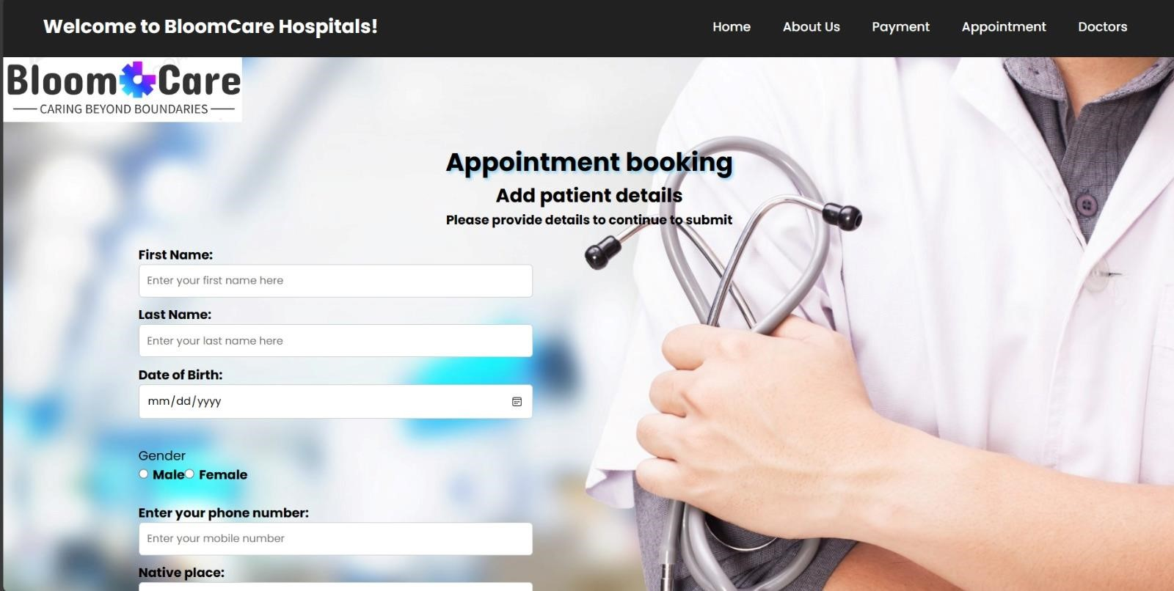

**About Us Page**

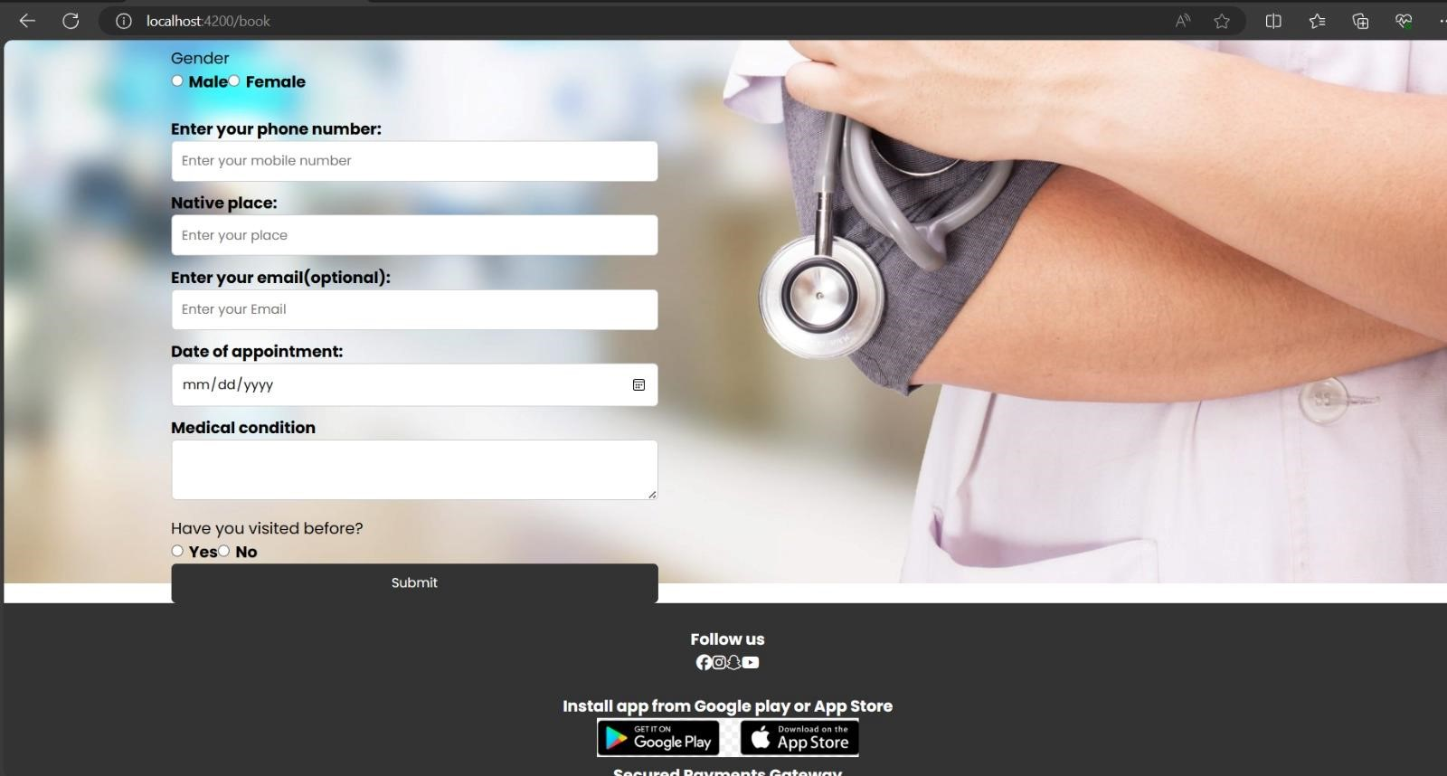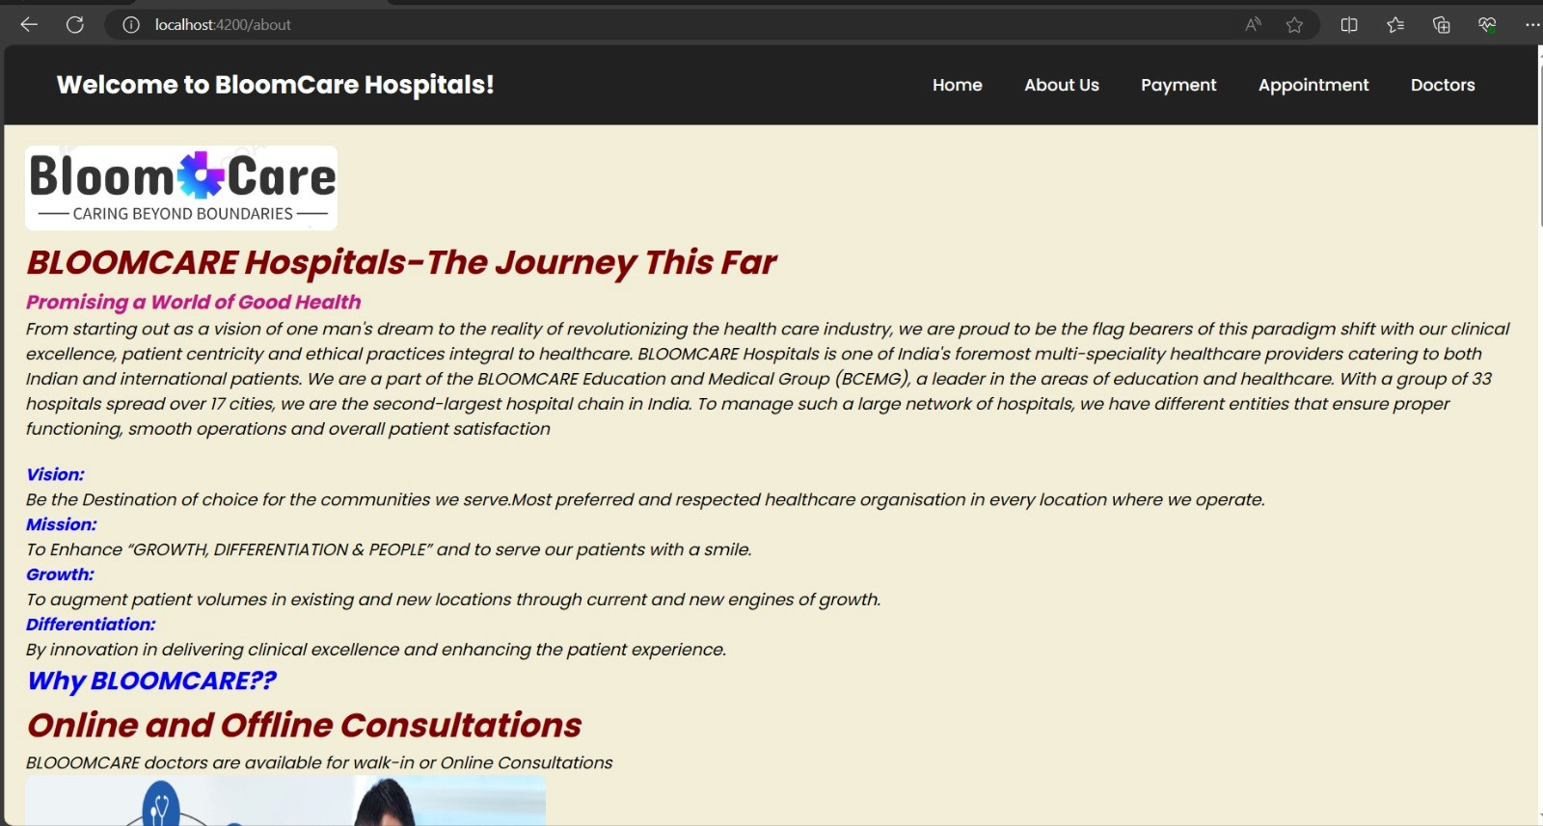

**Payment Page**

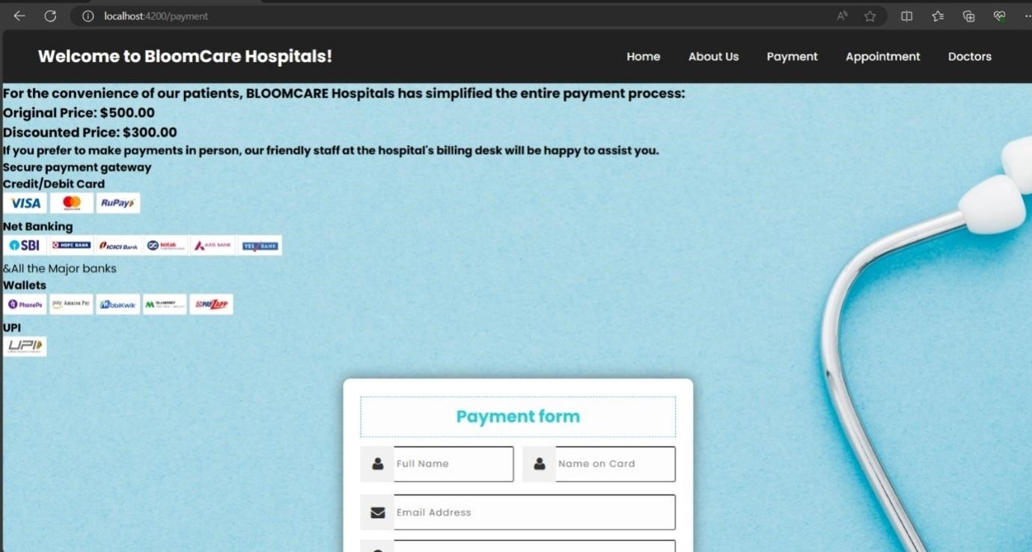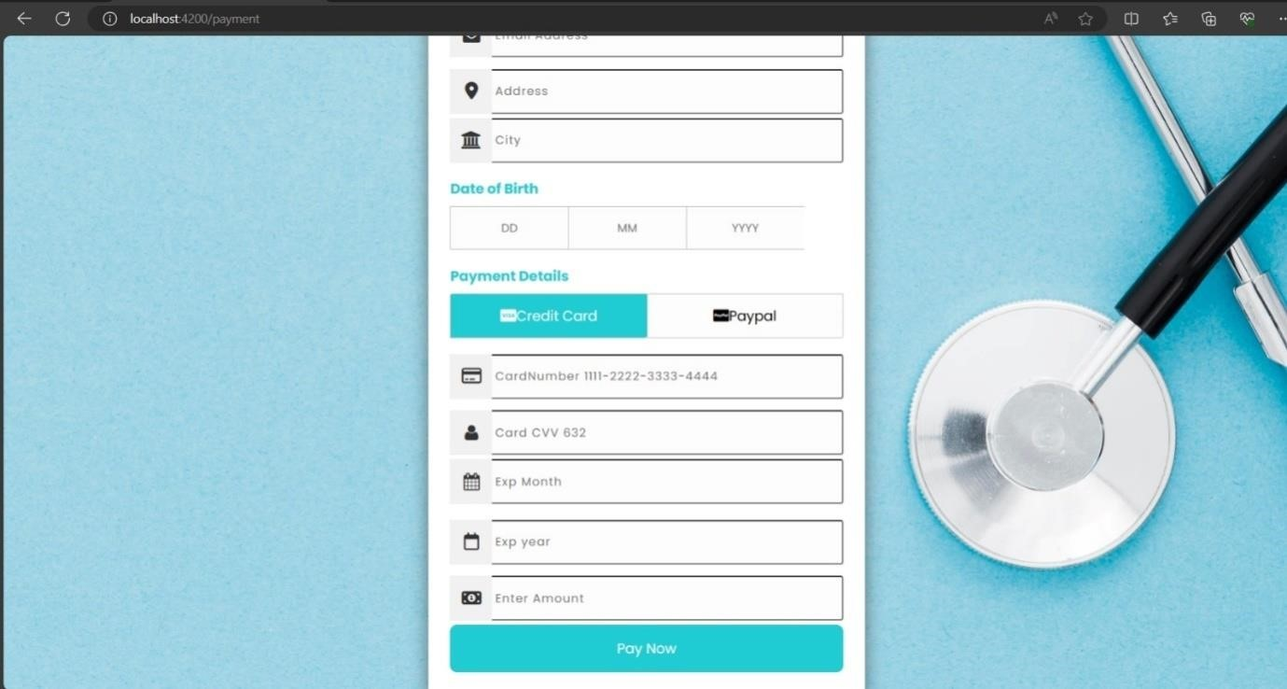

**Doctor Page**

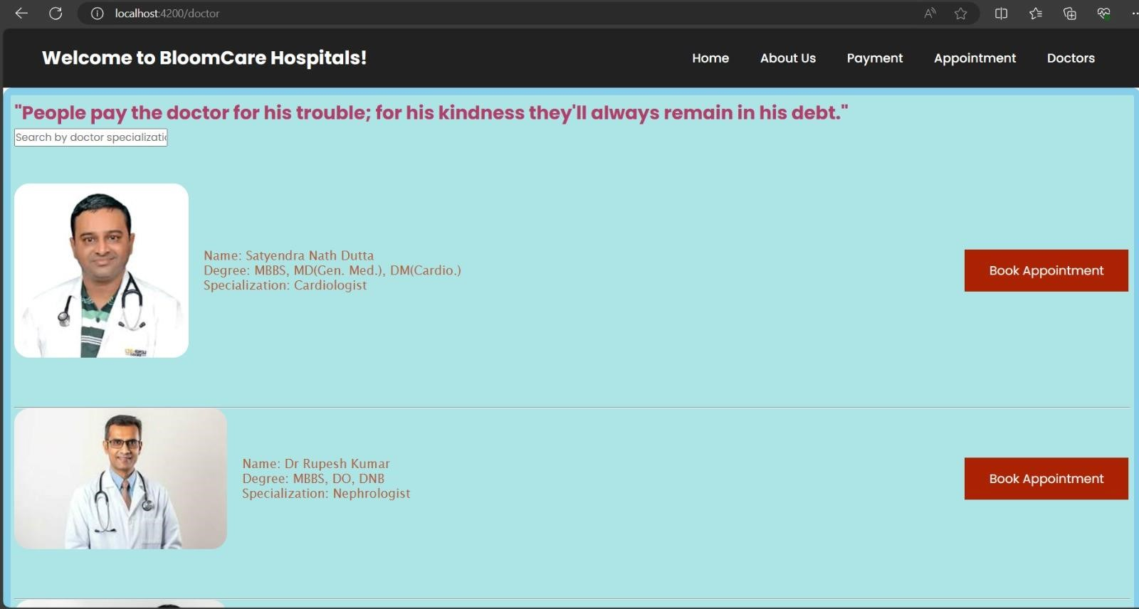

**Contact Us Page**

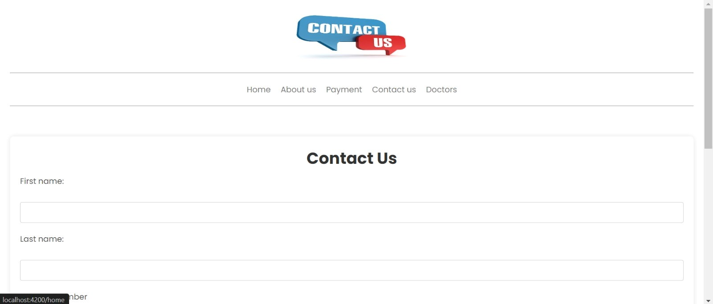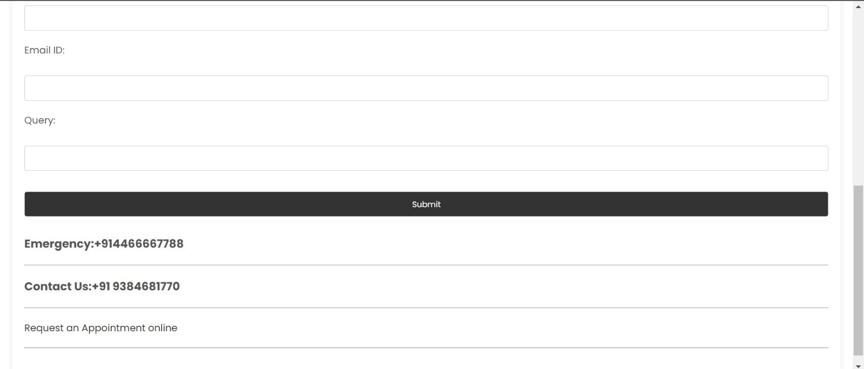

**Unit testing:**

for login.component.spec.ts,

import { ComponentFixture, TestBed } from '@angular/core/testing'; import { LoginComponent } from './login.component'; import { CommonModule } from '@angular/common'; import { FormsModule } from '@angular/forms';

describe('LoginComponent', () => { let component: LoginComponent; let fixture: ComponentFixture<LoginComponent>;

beforeEach(() => {

TestBed.configureTestingModule({ declarations: [LoginComponent], imports: [CommonModule, FormsModule]

});

fixture = TestBed.createComponent(LoginComponent); component = fixture.componentInstance; fixture.detectChanges();

});

it('should create', () => { expect(component).toBeTruthy();

});

it('should redirect to home with valid credentials', () => { component.username = 'validUsername'; component.password = 'validPassword';

component.login();

// Since we're not using a real router, we can't test navigation directly // So we can only check if no error message is displayed for valid credentials expect(component.errorMsg).toEqual('');

});

it('should display error message with invalid credentials', () => { component.username = 'invalidUsername'; component.password = 'invalidPassword';

component.login();

expect(component.errorMsg).toEqual('Invalid Credentials');

});

it('should display error message with empty username', () => { component.username = ''; component.password = 'validPassword';

component.login();

expect(component.errorMsg).toEqual('Username is required');

});

it('should display error message with empty password', () => { component.username = 'validUsername'; component.password = '';

component.login();

expect(component.errorMsg).toEqual('Password is required');

});

});

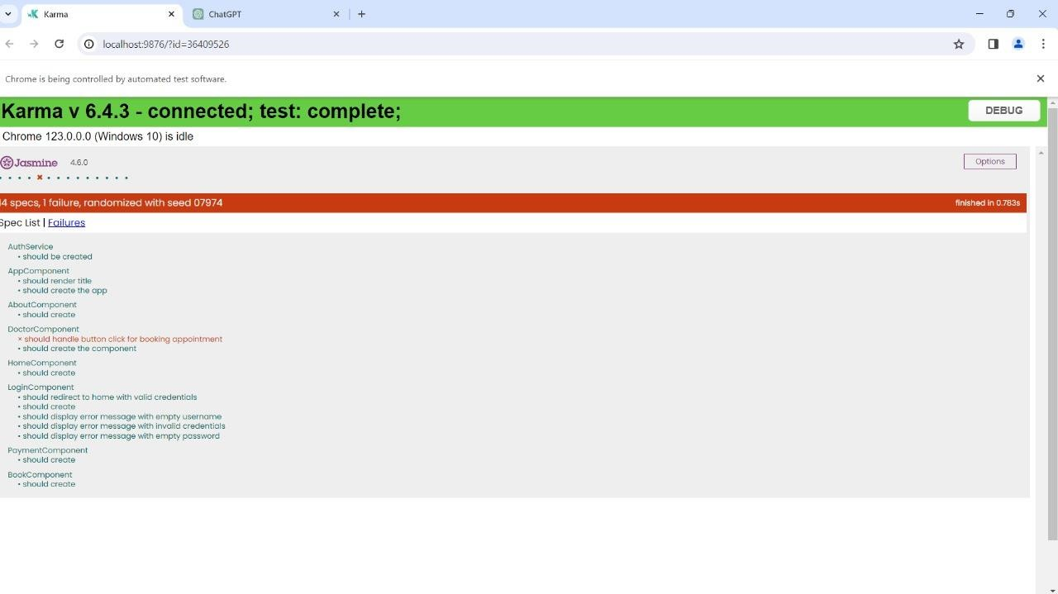

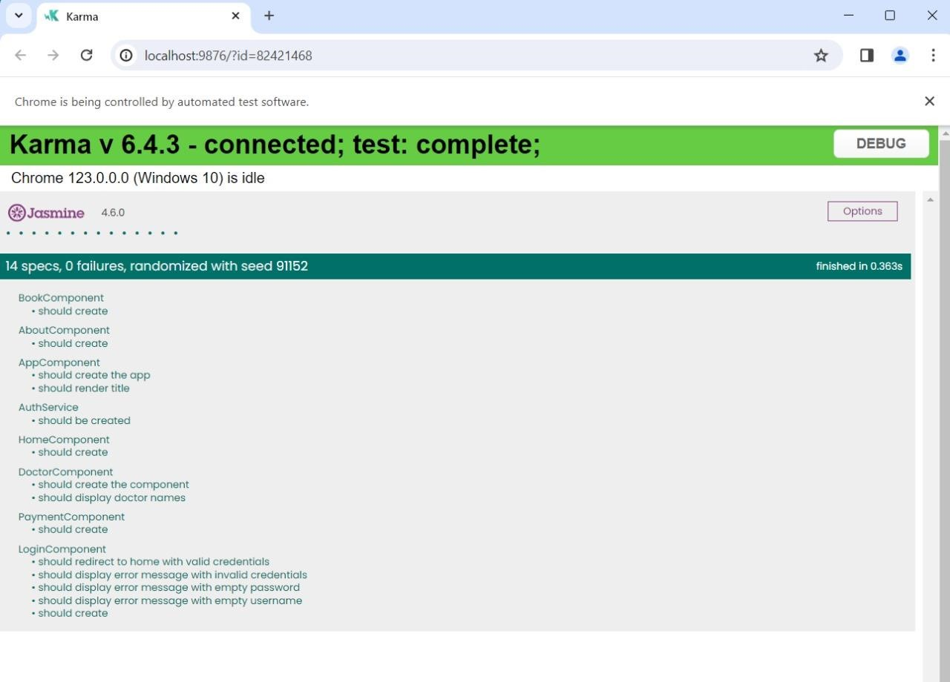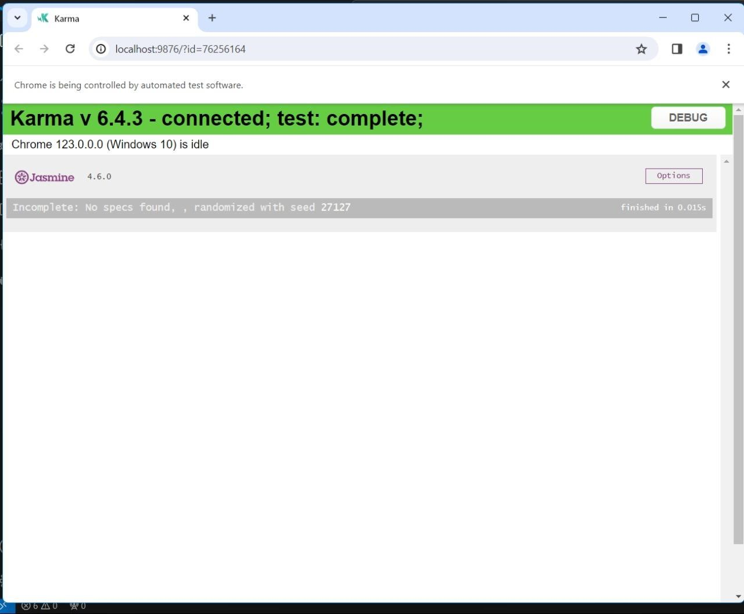

**Conclusion:**

In summary, the development of Bloom Care Hospital's website using AngularJS SPA has resulted in a dynamic and user-friendly platform. With pages including Login, Home, Contact Us, Payment, Doctors, Appointment, and About Us, the project offers a comprehensive solution for patients and healthcare professionals alike. Through secure login mechanisms, engaging interfaces, seamless appointment booking, and detailed doctor directories, the website prioritizes user experience and accessibility. Overall, the Bloom Care Hospital website stands as a testament to our commitment to leveraging technology to enhance healthcare delivery and patient engagement.